1. Why does the discussion of a hand drawn conceptual sketch of the “possible” layout of the VC1 parcel and the southern Buck Lake shoreline appear under the heading of “*Developer’s Report*”? Are we now the “*Developer*”?
2. The “MOTION” to limit website record listings to the last seven (7) years does not state that the mere “existence” of older records cannot be acknowledged! And that is all that the new paragraph on the *Ancillary Records* page does.

I forgot the words of Lincoln: “*You can please all of the people some of the time; and some of the people all of the time; but you cannot please all of the people all of the time.*” I did what I said I would do: *remediate PDFs*. I’m tired, so it’s time for me to step aside, let the BC & DM decide what they want on each webpage, & let the DM’s people handle setting it up their way.

1. Please explain exactly what your personal objection is to the *UserWay* plugin. Don’t recite “reports” that you may have read. Explain exactly what it does, in your opinion, that is “wrong” or “bad”. Why is it “unworthy” of use on our site?

* It was never promoted (at least not by me) as a “magic bullet” that could turn a non-compliant site into a compliant one. That is not its purpose, nor its function.
* As I have stated repeatedly (and this either went over your head, or you chose to clamp your hands over your ears), its sole utility is as an “aid” to a specific class of user; namely, those with very poor eyesight but who are not totally blind.  
  *Put on DARK sunglasses; then try out the Contrast, Text Size, & Character Spacing functions.*

*My opinion was: the icon should be the “eye”, & should be located in the upper-right-corner.  
With the DM’s help, Gary Hutton set this up. The final tweak would be to use a smaller icon.*

* We have gone to extreme lengths, with notations on literally every page, to make it clear that people-with-disabilities are welcome on our website; and that we are available & willing to help with anything they need. This “widget” is just another example of, and confirmation of, our commitment to that pledge.

1. Why is a “*permanent place for Field Services*” still an issue? I thought that the Board had authorized the purchase of a new trailer. If we are renting, why? If we need a concrete slab to set the trailer on, then install it, buy a trailer, & set it on it. What “additional” expenditure of funds are you angling for?
2. Multiple times you have been called-to-task by former and current members of this board for the overbearing, belligerent, & condescending way that you treat people and go about things. That was in the past. Now it seems you feel you can do it with impunity because you have a “brain-washed” cabal to back you.
3. You have a demonstrated propensity for deprecating anything that you did not originate and anyone who disagrees with you. Can you define “*deprecate*”? It means to *disparage* and *belittle*; and when confronted, you are quite good at it.

* **Future Facilities** **Building Escrow Fund** – Include **Placeholder** in **Budget!**   
  **Make Yearly Contributions** – **Starting** In Fiscal Year **2020!**

{ **Land** Available and Streetlight **Loan Payoff** Done }

* **Walking Pathway** **Behind Neighborhood F** – **Cost** to update; **funding** source**?**   
  Would serve as **Feeder Path** to new **Boardwalks** and **Piers**.
* **Engineering Report** **2012 Version Outdated** – Need to **Correct Parcel Zoning!**   
  **Exhibit-4 Map Wrong** for BL1, H1, H2, O, VC1, & Others.
* **Street Names Map** **Font Size & Line Weight** – Should **increase** for **readability**.   
  **Pond Colors** – **Change** **Dark Blue** to make **ID’s readable!**
* **Graphic Updates** **Version Availability** – Need to **Revise** District **Documents**.   
  **Engineer** to make **Fall Update** & add new **Neighborhoods**.
* **RC Camera Drone** **Buy** ≥10Mp HD camera (**cost:** helicopter system **≈$1000**)   
  CDD ownership **enables** on-demand facilities **monitoring**.

{ View Fields, Trails, Boats, Docks, Lakes, & Ponds }

* **Projector & Screen** **Buy** 16**:**9 aspect ratio (**cost:** projector **≈$500**; screen **≈$100**)   
  CDD ownership **assures** equipment access & **availability**.

{ Procurement May Become Critical With Developer Change }

* **Resident Directory** **Resident Business** – Has Developer initiated an update?   
  **Resident Names** – Any possibility of a complete version?
* **Community Artwork** **Deteriorating Condition** – Beautification & liability **Issues**:   
  **Ownership** & responsibility now **clearly** assigned to **CDD?**
* **Developer Liaison** **Authorization** – Board member contact outside of meetings:   
  Is member acting in that role designated to do so by Board?  
  To **formalize** process, **Move** that **Chairman** be designated**!**

**Undeveloped Tract**

* Area Location Bounded by Schoolhouse, Butterfly, Galaxy, & Sundrop

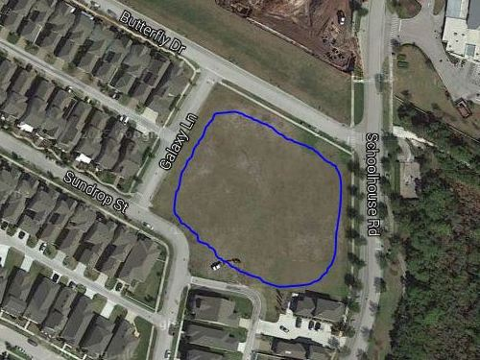

* Area Ownership Currently Developer property! District acquire/share it?
* Utilization Limited Currently used for school and personal overflow parking
* Usage Deficiencies Grading & fill needed to support structural development?
* Plausible Alternatives Softball Field, Skateboard Park, or Swim Facility (original)   
   Land requires nothing – except a commitment to use it!
* Development Budget Would seem to be an appropriate place for investment   
   Any possibility of cost sharing by District & Developer?
* Engineer Plat Layout Same detailed drawing quality as supplied for pipeline   
   Need “OK for Playground” confirmation by Engineer